

# **Individual Work**

#2

Topic: Video-Editor Application

Student’s name: Victor

Student’s surname: Vinogradov

St. code: ST79076

Lecturer: Karina Kostjkina

Contents

**Individual Work** 1

1. Introduction 3

2. Task for Laboratory Work 3

3. Subject Area Analysis 5

4. Design 7

4.1 Name and Brand 7

4.2 Structure and Layout 7

4.3 Colour Scheme 8

4.4 Relations Between Components 8

4.5 Fonts 9

4.6 Media 9

4.7 Uniform Styling 9

5. Development 9

5.1 Main Application Window Purpose: 9

5.2 Import/Export Videos 10

5.3 Playback Controls 11

5.4 Timeline and Track Management 12

5.5 Cutting and Deleting Video Segments 13

5.6 Zooming and Panning 15

6. Testing 16

7. Conclusions 17

## 1. Introduction

The Course Work is devoted to elaborating a Video Editor application according to the regulation of an assignment. Since the appearance of digital media, skills in video editing become very important for a vast class of users—from professions related to content creation to casual users willing to enhance their videos. The goal of the project is to create a powerful but, at the same time, accessible application for recording, editing, saving video materials, etc. Such a goal should result in developing an application that can perform only basic functionalities expected from video editing—not more than that. There is no application complexity and steep learning curve typical of a professional video editing application. Provisioning of the application from the early planning and design to final implementation and testing is developed. This application is developed on Java Swing as a graphical user interface for a desktop video editing application, including implementing some other libraries—VLCJ for video playing, FlatLaf for modern interface aesthetics, and FFmpeg for video processing. In this case, selected technologies can support the robustness, responsiveness, and visual appeal of the application.

## 2. Task for Laboratory Work

The task for the laboratory work involves the development of a desktop-based video editor application with the following objectives and requirements:

**OBJECTIVE:**

- Develop a practical and user-friendly video capturing, editing, and saving tool.

- Provide basic and needed functionalities without the complexity that the other tools, considered professional software, are integrating.

- Serve every class of the user, even the novice user, depending on his experience.

**Feature Requirement:**

Video Import/Export to Editor

Import Video: Users can import video files located in local storage to the editor.

Export Video: The capability to export the edited videos back into their local storage.

Video Details: Display all details related to the videos, including length, size, and name.

Playback Controls:

Play, Pause, Replay: Implement the most elementary form of controls for playing, pausing, and replaying video content.

Editing Features:

Clip Feature: Implement a clip feature to snip out the clips from the video. Clips should be made on marked points.

Delete Feature: Implement a delete feature to delete the clips.

Timelines and Tracks:

View of Timeline: The system will be able to view the timeline for the video graphically.

Options available for Control Panel of Tracks: Multiple video tracks can be controlled and viewed.

Zooming and Panning:

Zoom In/Out: Implement zoom in and out for editing in a detailed view.

Panning: Use this characteristic to pan through the timeline and navigate the video.

Background Loading:

Background Loading: Load thumbnails and waveforms in the background and provide a responsive user interface.

Tools and Technologies:

Java Swing: For implementing the Graphical User Interface.

VLCJ: For the rendering of video and media controls.

FlatLaf: For a modern and consistent look and feel.

FFmpeg: For video processing and editing tasks.

IntelliJ IDEA: This is an integrated development environment developed for the project.

## 3. Subject Area Analysis

**Introduction**

The subject area of the given project is the development of a desktop application for video editing. The significance of video content in the modern digital era is vast and present everywhere—social networks, education, marketing, and entertainment. So, proportionally increased is the demand for accessibility of video-editing tools, and as a result, the development of solid yet simple-to-use applications has simply become a necessity.

**Market Need**

There are many professional tools on the market for video editing, such as Adobe Premiere Pro, Final Cut Pro, DaVinci Resolve, and so on. Most of them are for professional users with deep requirements for features, so they are complex or require a steep learning curve. At the same time, casual users and content creators find many such tools overwhelming since they need to get their basic tasks done effectively and quickly.

**Swing Video Editor App Audience**

The Swing Video Editor App is for:

Casual Users: People needing to perform video editing tasks like cutting, trimming, or any of the above for their videos.

Content Creators: YouTubers, Bloggers, Social Media Influencers, or anyone with a regimen of creating video content.

Educators: Teachers and Trainers who make instructional videos.

Professionals: People who need video editing for presentations, marketing, or internal communication.

**Swing Video Editor**

Swing Video Editor is an application developed to support functionalities that naïve users seek in video editing software, like:

1. Import and export of video files.

2. Basic play controls

3. Cut and delete video segments

4. Visualization of video timelines with the ability to zoom and pan, etc.

**Features of Swing Video Editor**

Import/Export of videos: Easy to import videos from local storage and export back the edited videos to the local storage.

Playback Controls: Basic play, pause, and replay for the videos in the editor.

Editing Functions: Cut and Delete the segments into the footage in correct editing.

Timeline and Track Management: Visualized timeline representing the video and panel with tracks to manage the different segments of the video.

Zoom and Pan: Zoom in and out on the timeline to pan for detailed editing.

**Challenges and Solutions**

Video Processing Complexity

Challenge: The tasks related to video processing cause a great deal of complexity, and it could at this moment be quite complex and resource-costly to find some efficient means of doing them.

Solution: Make the feature-rich, high-performance video processing real with the FFmpeg infrastructure.

User Interface Design

Challenges: Come up with user interfaces that can be friendly to any user level; even the experts should find the user interface intuitive.

Solution: Develop an up-to-date UI design with FlatLaf and follow the best UI/UX design practices.

Performance Optimization

Challenge: The application is supposed to stay responsive to its users when involved in the different activities of background processing.

Solution: To achieve this, loading of the thumbnails and waveforms will be done using the background threading.

Conclusion

Therefore, an evaluation of the subject area is an eye-opener showing that the development of the Video Editor application becomes a necessity and is relevant to open up to a versatile class of users. Swing Video Editor, on the other hand, helps to contribute to filling this gap that exists in the market due to being efficient and easy with video editing. Works on its design by giving the core features a lead in conjunction with a user-friendly design.

## 4. Design

### 4.1 Name and Brand

Application Name: Swing Video Editor

The name "Swing Video Editor" reflects the use of Java Swing for the graphical user interface (GUI), emphasizing the application's focus on video editing functionalities. The brand aims to convey simplicity, efficiency, and accessibility, targeting a broad audience from casual users to professionals.

### 4.2 Structure and Layout

The user interface is designed to be intuitive and user-friendly, ensuring that users can easily navigate and utilize the application's features. The layout is divided into several key components:

Control Panel:

Location: Left sidebar

Components:

Import Button: Allows users to import videos into the editor.

Export Button: Allows users to export edited videos.

Cut Button: Allows users to cut segments of the video.

Delete Button: Allows users to delete selected segments of the video.

Control Panel:

Location: Above Video Player

Components:

Play/Pause Button: Toggles video playback.

Replay Button: Restarts video playback from the beginning.

Zoom In Button: Zooms into the timeline for detailed editing.

Zoom Out Button: Zooms out of the timeline for a broader view.

Video Display Area:

Location: Central area of the main window

Components:

Embedded Media Player: Displays the video for playback and editing, utilizing VLCJ for video playback.

Timeline Panel:

Location: Bottom section of the main window, above the track panel

Components:

Time Markers: Displays the timeline of the video with major and minor tick marks.

Red Cursor: Indicates the current playback position within the timeline.

Zooming and Panning: Allows users to zoom in and out, and pan through the timeline.

Track Panel:

Location: Directly below the timeline panel

Components:

Video Tracks: Displays the different tracks and segments of the video.

Thumbnails: Provides a visual representation of video segments.

Waveforms: Shows audio waveforms for video segments.

Selection and Editing: Allows users to select, cut, and delete video segments.

### 4.3 Colour Scheme

The color scheme is designed to be professional and visually appealing, ensuring good contrast and readability.

Background: Dark grey (#3C3F41) for a professional editing environment.

Buttons: Dark grey with white text for better contrast.

Timeline and Track Panels: Slightly darker grey (#2E2E2E) to differentiate from the background.

Cursor: Red for high visibility against the dark background.

Text: White for clear readability against the dark background.

### 4.4 Relations Between Components

The components of the application are designed to work together seamlessly:

Control Panel: Provides user input to the MainController, which then updates the video playback and editing functionalities.

Video Display Area: Displays the current video, controlled by the MainController.

Timeline Panel: Shows the timeline and receives updates from the MainController.

Track Panel: Manages video tracks and segments, updated by the MainController.

### 4.5 Fonts

Primary Font: Arial or Helvetica, chosen for their readability and widespread availability.

Font Size: Consistent font size across the application for uniformity.

Font Color: White, to ensure clear readability against the dark background.

### 4.6 Media

Thumbnails: Represent video segments visually, generated using FFmpeg.

Waveforms: Visual representation of the audio track generated using FFmpeg.

Icons and Buttons: Use standard, recognizable icons for play, pause, cut, delete, zoom in, and zoom out functionalities.

### 4.7 Uniform Styling

Look and Feel: Utilizes FlatLaf for a modern, cohesive look and feel.

Consistent UI Elements: All buttons, panels, and text fields follow a consistent design language.

Responsive Design: Ensures that the application layout adapts smoothly to different window sizes and user actions.

## 5. Development

The Swing Video Editor application implementation process will be developed by preparing the development environment. These steps are to be followed in the same order: import/export video, video playback controls, timelines and track handling, development of video editing functions, development of logic for zooming and panning, and the development of background processing. The implementation process for each feature in the coming section is to be explained with required code fragments to explain where the feature is to be implemented.

### 5.1 Main Application Window Purpose:

Define the main application window through which users will be able to interface with the video editing system.

Implementation(fig.1): The main application window has been developed through Java Swing, which is a robust framework used for implementing GUI systems. Contains the following components:

Control Panel, Video Display Area, Timeline Panel, Track Panel

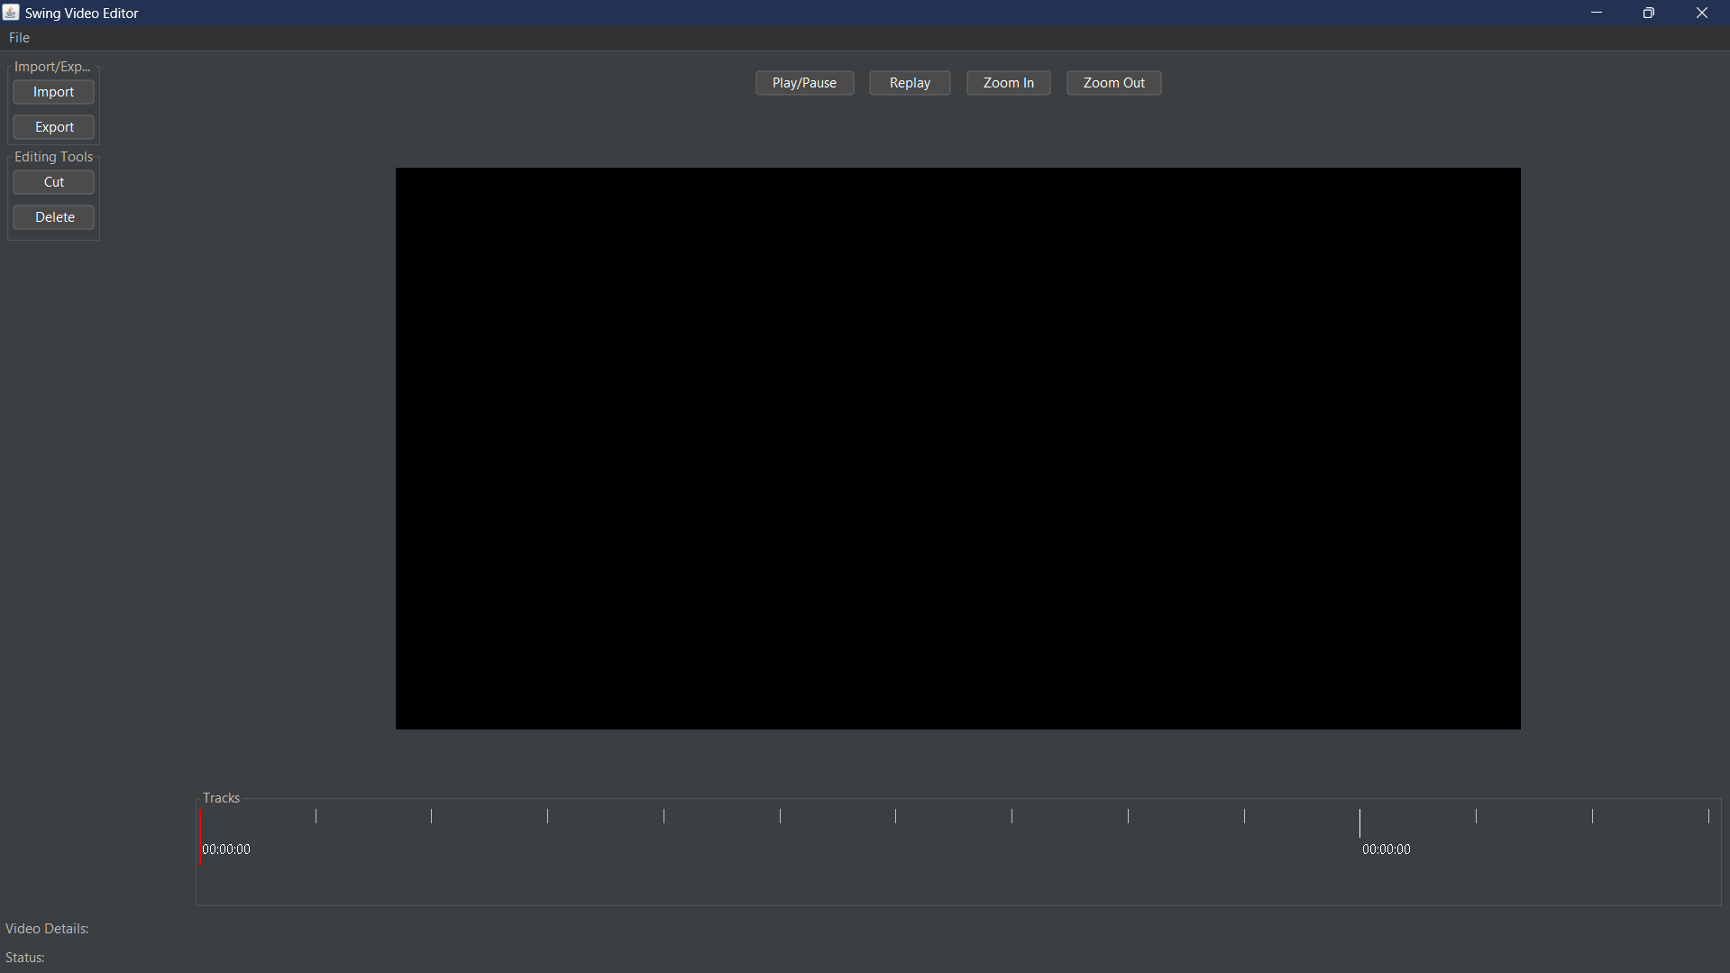

(fig.1)

### 5.2 Import/Export Videos

**Objective**: Implement functionalities to import and export videos.

**Implementation(fig.2)**:

Users can import videos from local storage using the Import Button(fig.3).

Edited videos can be exported back to local storage using the Export Button(fig.4).

Video details (length, size, name) are displayed upon import.

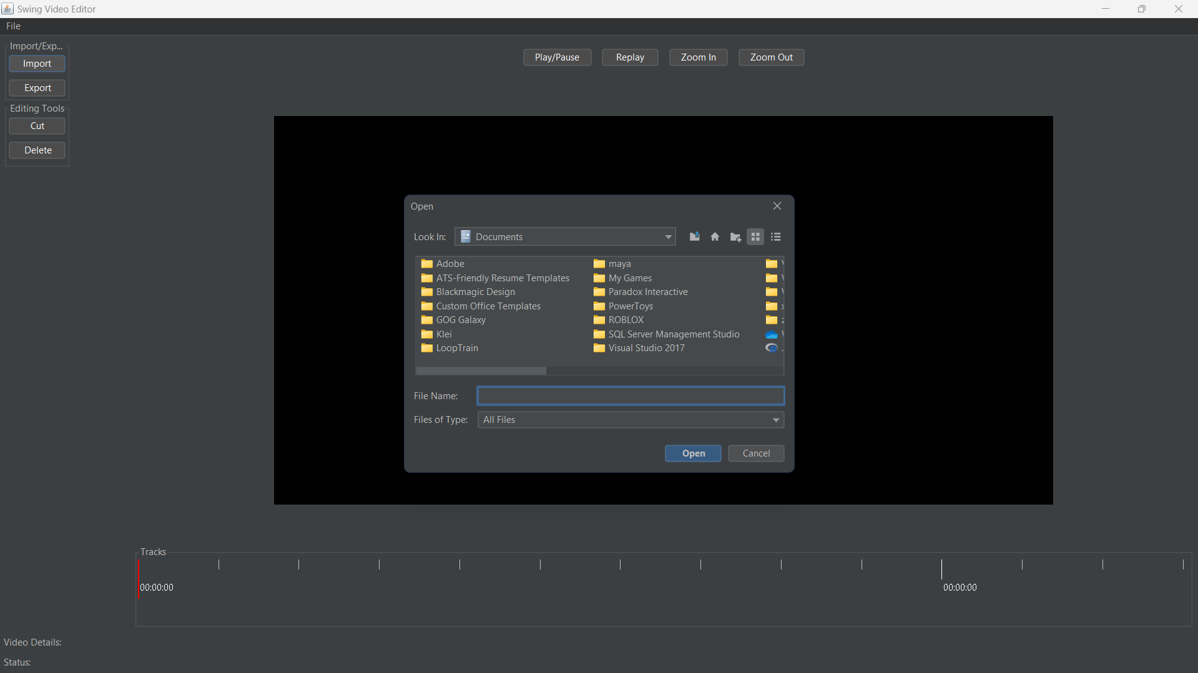

(fig.2)

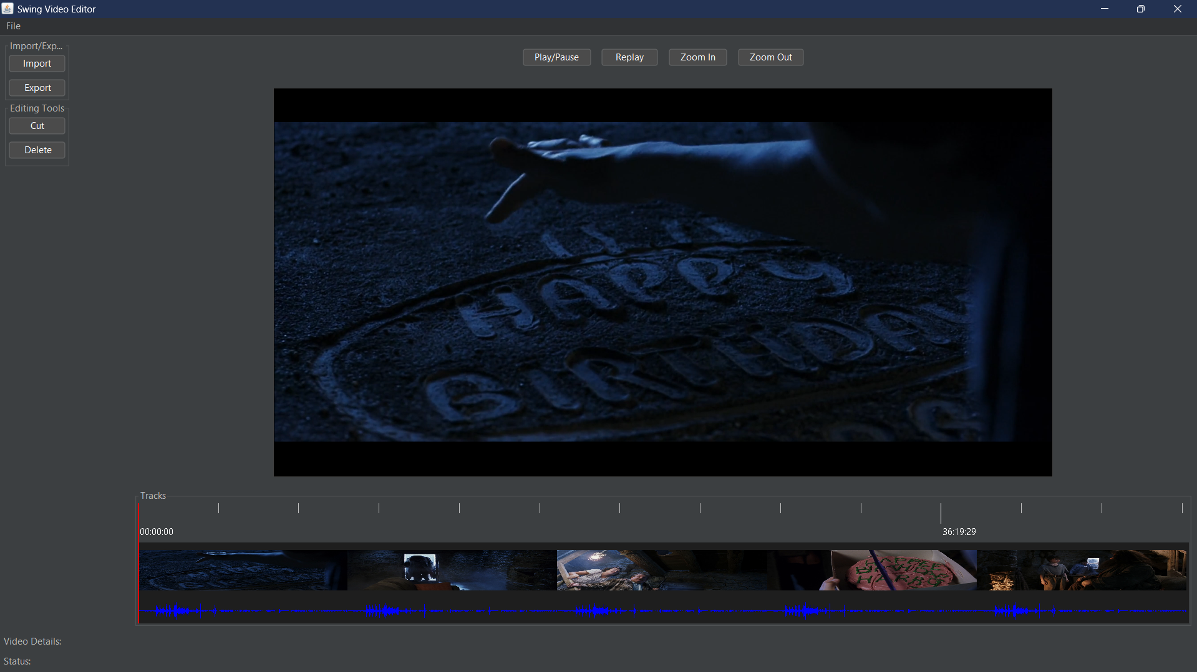

(fig.3)

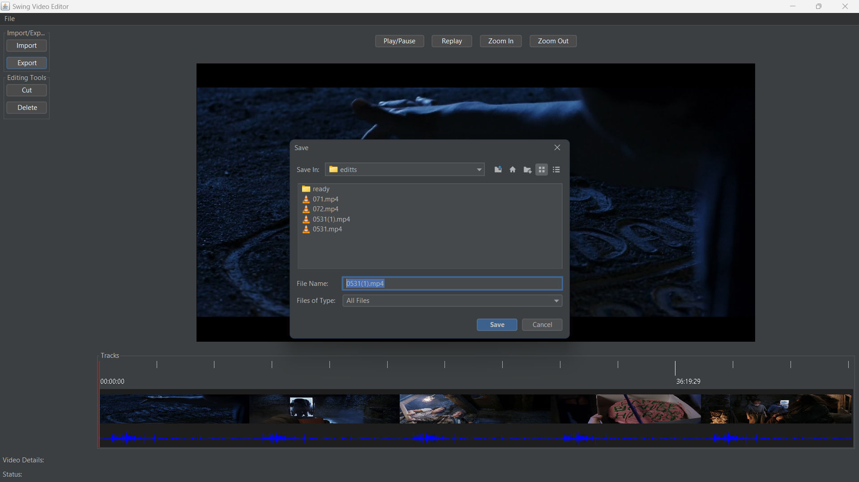

(fig.4)

### 5.3 Playback Controls

**Objective**: Implement basic playback controls (play, pause, replay).

**Implementation**:

The Play/Pause Button toggles between playing and pausing the video(fig.5).

The Replay Button restarts the video from the beginning(fig.6).

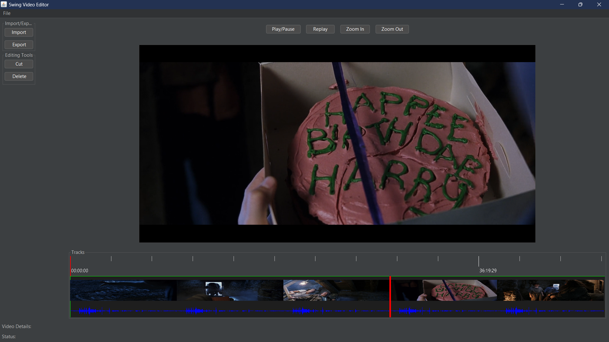

(fig.5)

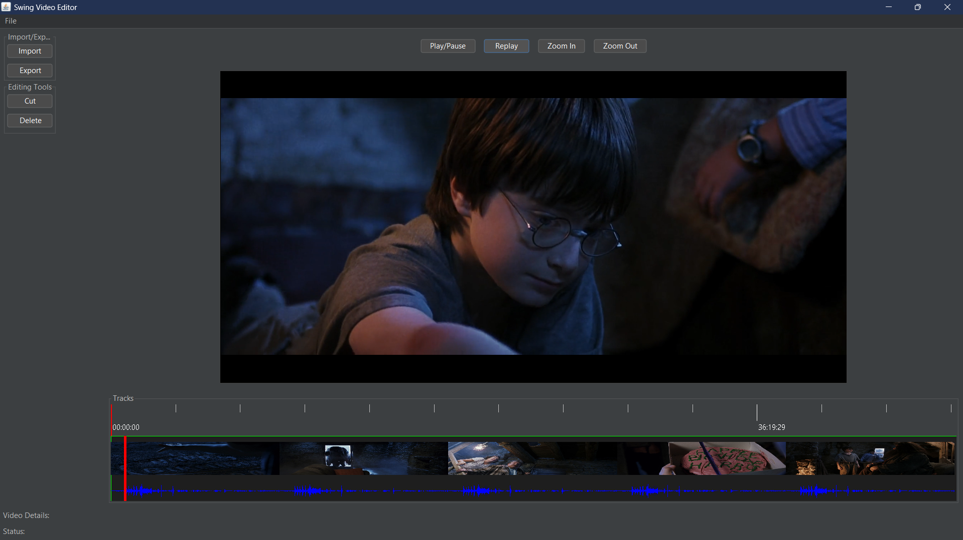

(fig.6)

### 5.4 Timeline and Track Management

**Objective**: Implement a visual representation of the video timeline and manage video tracks.

**Implementation**:

The Timeline Panel displays the video timeline with time markers and a cursor(fig.7).

The Track Panel manages different video tracks and segments, displaying thumbnails and waveforms(fig.8).

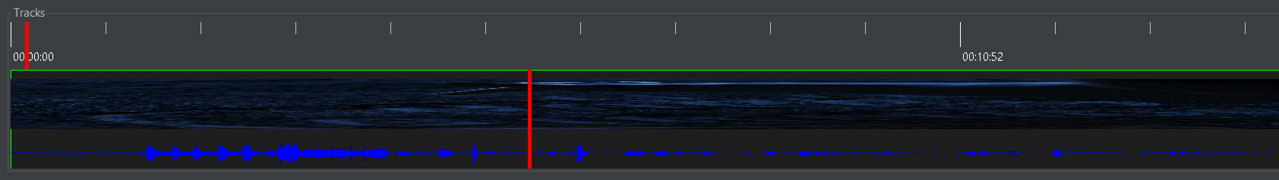

(fig.7)



(fig.8)

### 5.5 Cutting and Deleting Video Segments

**Objective**: Allow users to cut and delete video segments.

**Implementation**:

The Cut Button allows users to cut segments of the video by choosing, cut appears in place where red cursor is set.(fig.9).

User can Select segments by clicking on them, selected will highlight with green(fig.10).

The Delete Button allows users to delete selected segments of the video(fig.11).

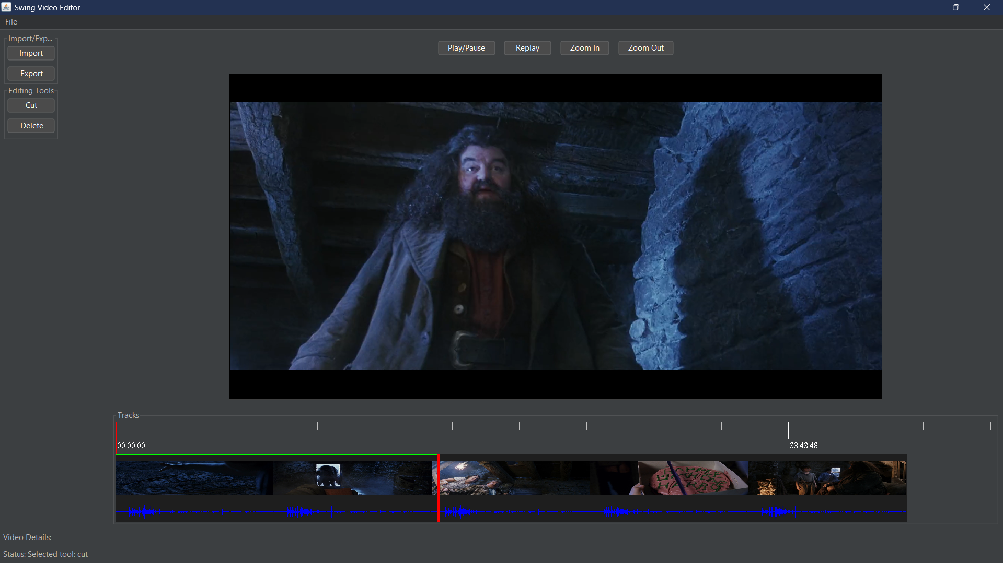

(fig.9)

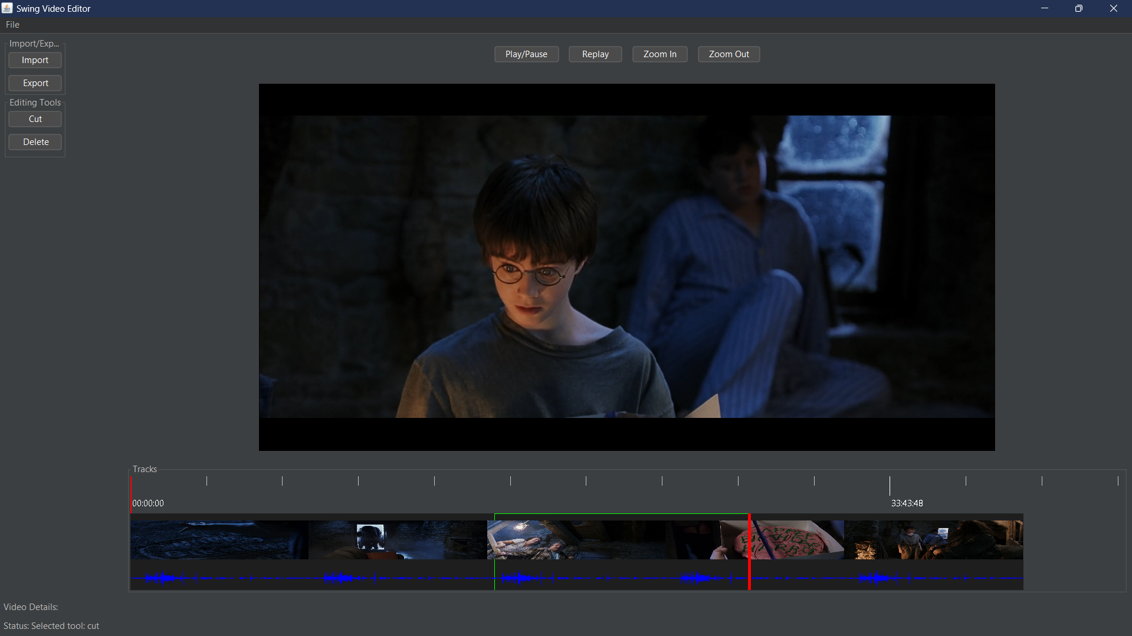

(fig.10)

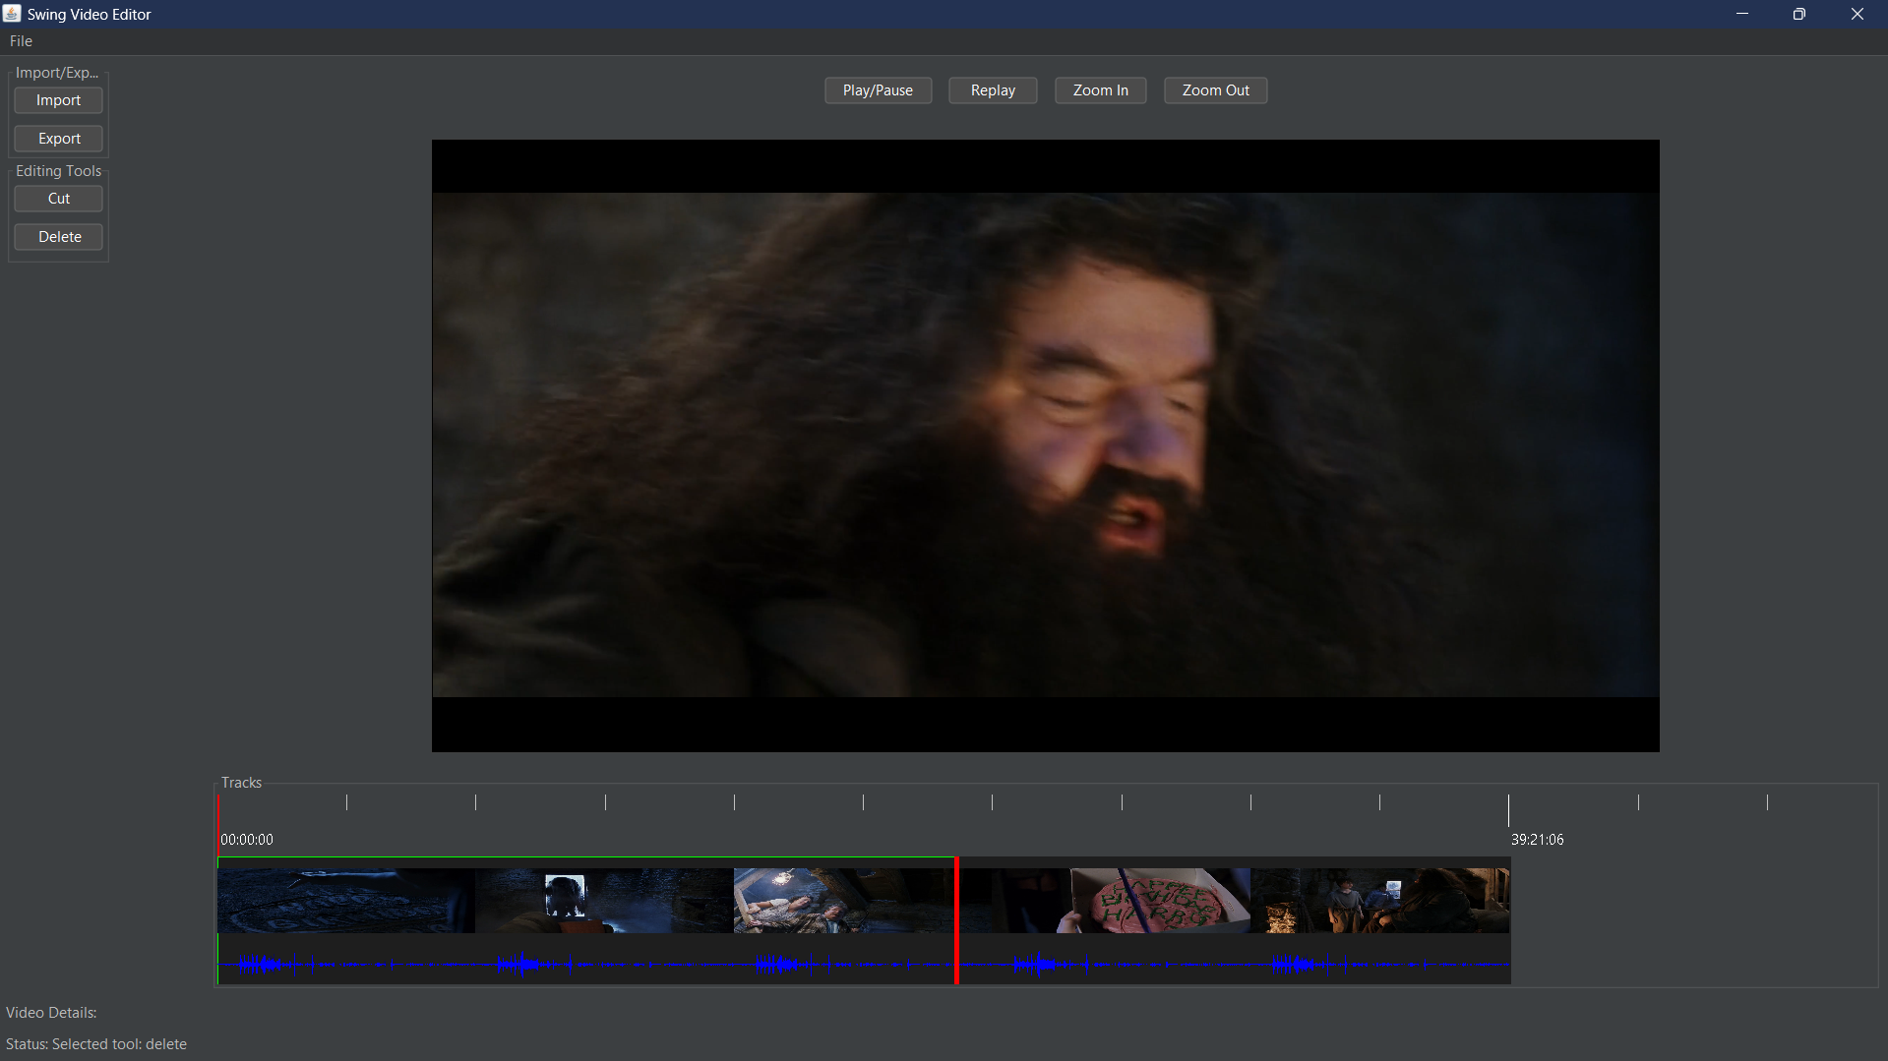

(fig.11)

### 5.6 Zooming and Panning

**Objective**: Implement zooming and panning functionalities for detailed editing.

**Implementation**:

The Zoom In Button and Zoom Out Button allow users to zoom in and out of the timeline(fig.12).

Panning is achieved by dragging the timeline(fig.13).

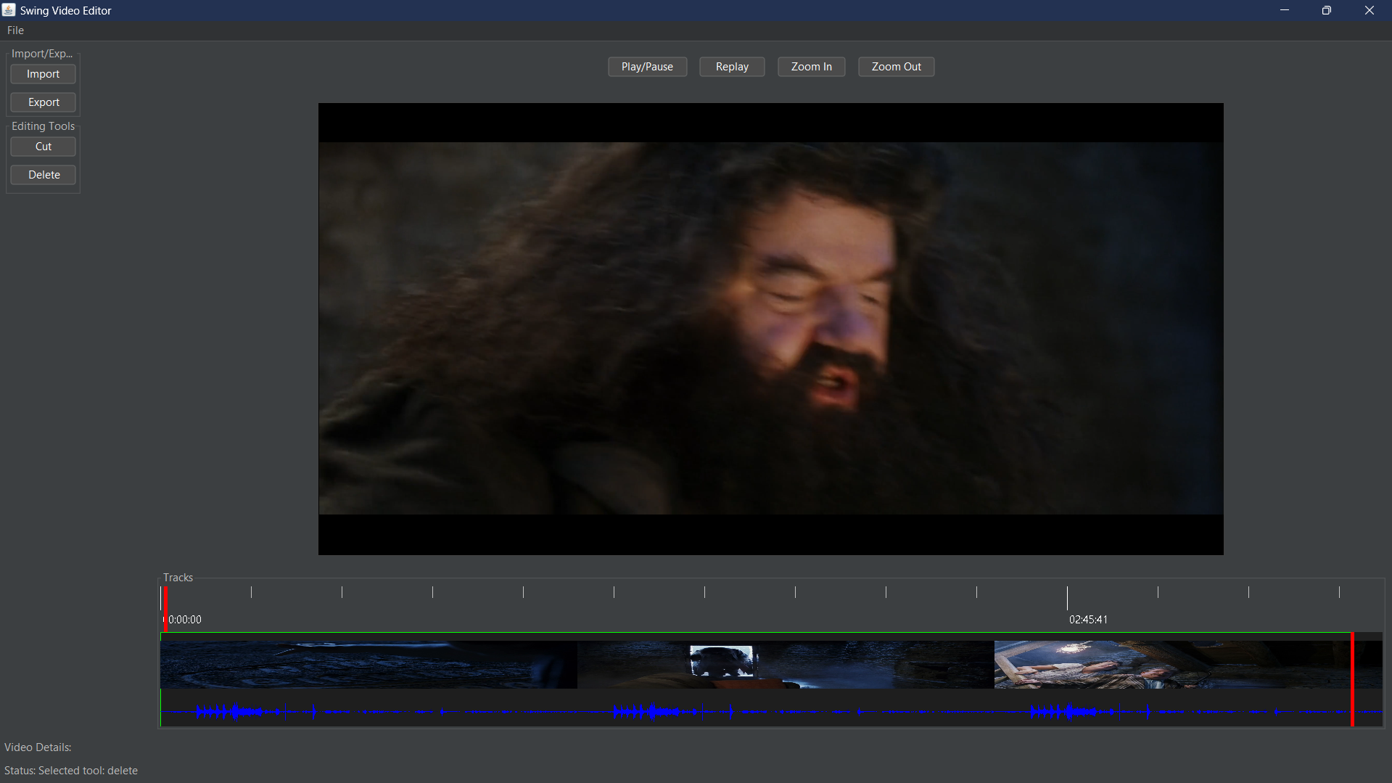

(fig.12).

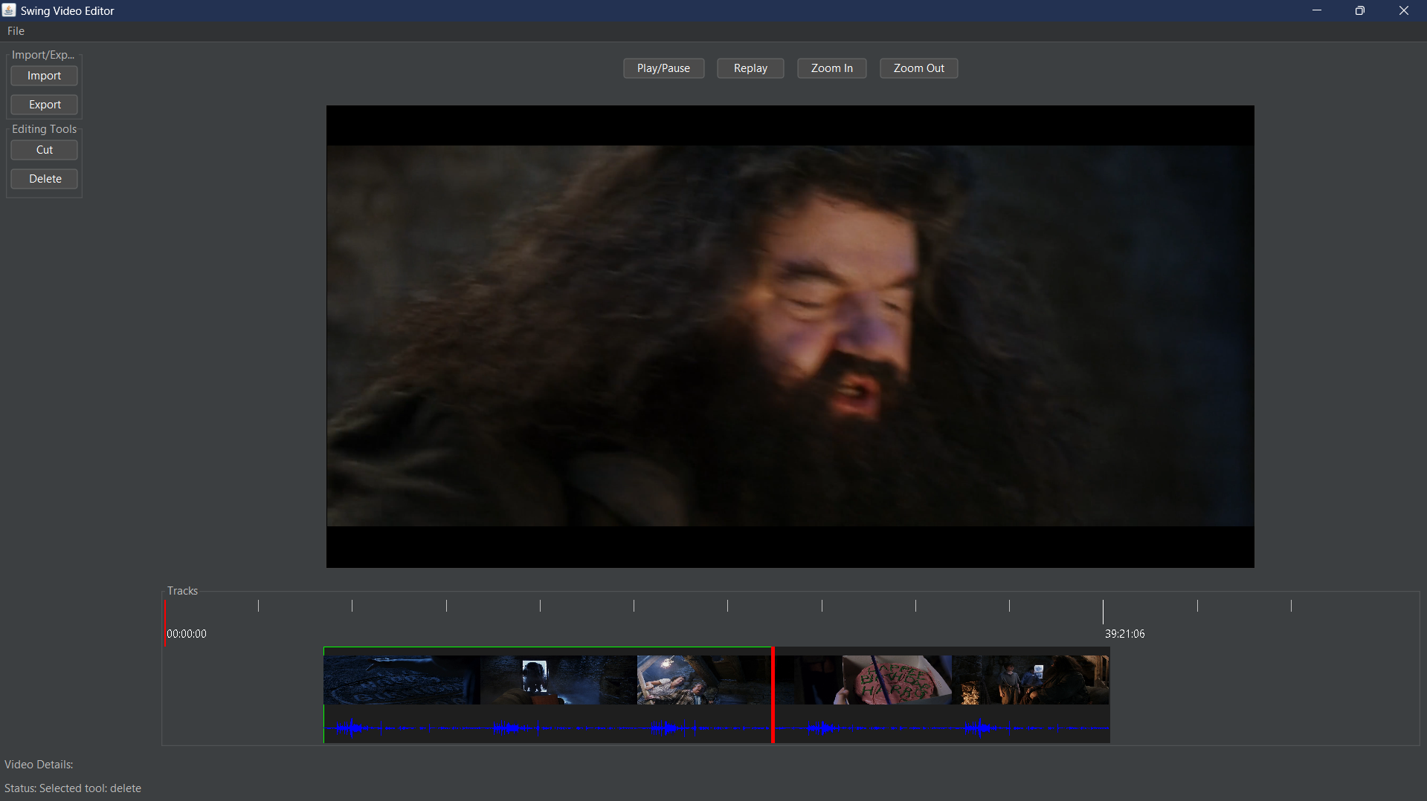

(fig.13)

# 6. Testing

Test Case #1: Import Video

**Objective**: Verify that videos can be imported correctly.

**Steps**: Import a video file from local storage.

**Expected Result**: The video is loaded and displayed in the editor.

Test Case #2: Export Video

**Objective**: Verify that edited videos can be exported.

**Steps**: Export the currently edited video.

**Expected Result**: The video is saved to local storage.

Test Case #3: Playback Controls

**Objective**: Verify playback functionalities.

**Steps**: Use play, pause, and replay buttons.

**Expected Result**: The video plays, pauses, and replays as expected.

Test Case #4: Editing Functions (Cut/ Delete)

**Objective**: Verify cutting and deleting functionalities.

**Steps**: Cut and delete segments of the video.

**Expected Result**: The specified segments are cut or deleted.

Test Case #5: Zooming and Panning

**Objective**: Verify zooming and panning functionalities.

**Steps**: Zoom in/out and pan through the timeline.

**Expected Result**: The timeline zooms and pans smoothly.

Results

The application was tested thoroughly, and all functionalities worked as expected.

## 7. Conclusions

This helped to develop a functioning video editor application with all of the features mentioned. The current goals were achieved, and the user-friendly interface to enable easy manipulations with video was set up. Even though the execution of the project is successful, the work can be improved in the future using advanced features of editing and the optimization of performance.

**8. References**

**VLCJ Library Documentation**

**FlatLaf Library Documentation**

**FFmpeg Documentation**

**Java Swing Documentation**

**ChatGPT**

**9. Annex**

**Main.java**

package com.videoeditor;  
  
import com.videoeditor.core.VideoEditor;  
import com.videoeditor.ui.MainController;  
import com.videoeditor.ui.MainView;  
  
import javax.swing.*;  
import java.util.logging.ConsoleHandler;  
import java.util.logging.Level;  
import java.util.logging.Logger;  
  
public class Main {  
 private static final Logger *logger* = Logger.*getLogger*(Main.class.getName());  
  
 public static void main(String[] args) {  
 *configureLogging*();  
 SwingUtilities.*invokeLater*(Main::*initializeApplication*);  
 }  
  
 private static void configureLogging() {  
 // Configure logger to show messages in the console  
 ConsoleHandler consoleHandler = new ConsoleHandler();  
 consoleHandler.setLevel(Level.*ALL*);  
 *logger*.addHandler(consoleHandler);  
 *logger*.setLevel(Level.*ALL*);  
 }  
  
 private static void initializeApplication() {  
 try {  
 *logger*.log(Level.*INFO*, "Initializing Video Editor Application...");  
 VideoEditor videoEditor = new VideoEditor();  
 MainView mainView = new MainView(videoEditor);  
 MainController mainController = new MainController(videoEditor, mainView);  
 mainView.setMainController(mainController);  
 mainView.setVisible(true);  
 *logger*.log(Level.*INFO*, "Application started successfully.");  
 } catch (Exception e) {  
 *logger*.log(Level.*SEVERE*, "Application failed to start.", e);  
 JOptionPane.*showMessageDialog*(null, "Failed to start the application. Please check the logs for more details.",  
 "Error", JOptionPane.*ERROR_MESSAGE*);  
 }  
 }  
}

**MainController.java**

package com.videoeditor.ui;  
  
import com.videoeditor.core.VideoEditor;  
import com.videoeditor.model.Track;  
import com.videoeditor.model.TrackSegment;  
  
import javax.swing.*;  
import java.awt.*;  
import java.io.File;  
import java.util.ArrayList;  
import java.util.List;  
import java.util.logging.Logger;  
  
public class MainController {  
 private static final Logger *logger* = Logger.*getLogger*(MainController.class.getName());  
  
 private final VideoEditor videoEditor;  
 private final MainView mainView;  
 private Track track;  
 private File currentVideoFile;  
 private final Timer playbackTimer;  
 private List<TrackSegment> selectedSegments = new ArrayList<>();  
  
 public MainController(VideoEditor videoEditor, MainView mainView) {  
 this.videoEditor = videoEditor;  
 this.mainView = mainView;  
 this.mainView.setMainController(this);  
  
 this.mainView.getImportButton().addActionListener(e -> importVideo());  
 this.mainView.getExportButton().addActionListener(e -> exportVideo());  
 this.mainView.getPlayPauseButton().addActionListener(e -> togglePlayPause());  
 this.mainView.getReplayButton().addActionListener(e -> replayVideo());  
 this.mainView.getZoomInButton().addActionListener(e -> zoomIn());  
 this.mainView.getZoomOutButton().addActionListener(e -> zoomOut());  
 this.mainView.getCutButton().addActionListener(e -> cutSegment());  
 this.mainView.getDeleteButton().addActionListener(e -> deleteSelectedSegment());  
  
 playbackTimer = new Timer(100, e -> updateCursor());  
 }  
  
 public void importVideo() {  
 JFileChooser fileChooser = mainView.getFileChooser();  
 int result = fileChooser.showOpenDialog(mainView);  
 if (result == JFileChooser.*APPROVE_OPTION*) {  
 File file = fileChooser.getSelectedFile();  
 currentVideoFile = file;  
 videoEditor.importVideo(file);  
 mainView.getMediaPlayerComponent().mediaPlayer().media().startPaused(file.getAbsolutePath());  
  
 track = new Track();  
 double duration = videoEditor.getVideoDuration(file);  
 track.addSegment(new TrackSegment(file.getAbsolutePath(), "", 0, duration));  
  
 TrackPanel trackPanel = new TrackPanel(track, videoEditor, this);  
 trackPanel.setTrackPanelListener(this::seekToTime);  
 trackPanel.loadThumbnailsAndWaveformsInBackground();  
  
 mainView.getTrackPanel().removeAll();  
 mainView.getTrackPanel().add(trackPanel);  
  
 mainView.getTrackPanel().revalidate();  
 mainView.getTrackPanel().repaint();  
  
 mainView.getTimelinePanel().setTotalDuration((int) (duration * 1000));  
 }  
 }  
  
 private void seekToTime(double time) {  
 if (currentVideoFile != null) {  
 mainView.getMediaPlayerComponent().mediaPlayer().controls().setTime((long) (time * 1000));  
 mainView.getTrackPanel().getMousePosition();  
 }  
 }  
  
 public void exportVideo() {  
 JFileChooser fileChooser = mainView.getFileChooser();  
 int result = fileChooser.showSaveDialog(mainView);  
 if (result == JFileChooser.*APPROVE_OPTION*) {  
 File file = fileChooser.getSelectedFile();  
 videoEditor.exportVideo(currentVideoFile, file);  
 }  
 }  
  
 public void togglePlayPause() {  
 if (currentVideoFile != null) {  
 if (mainView.getMediaPlayerComponent().mediaPlayer().status().isPlaying()) {  
 mainView.getMediaPlayerComponent().mediaPlayer().controls().pause();  
 playbackTimer.stop();  
 } else {  
 mainView.getMediaPlayerComponent().mediaPlayer().controls().play();  
 playbackTimer.start();  
 }  
 }  
 }  
  
 public void replayVideo() {  
 if (currentVideoFile != null) {  
 mainView.getMediaPlayerComponent().mediaPlayer().controls().setTime(0);  
 mainView.getMediaPlayerComponent().mediaPlayer().controls().play();  
 playbackTimer.start();  
 }  
 }  
  
 public void zoomIn() {  
 zoom(1.1);  
 }  
  
 public void zoomOut() {  
 zoom(0.9);  
 }  
  
 private void zoom(double factor) {  
 Component trackComponent = mainView.getTrackPanel().getComponent(0);  
 if (trackComponent instanceof TrackPanel) {  
 ((TrackPanel) trackComponent).setZoomLevel(((TrackPanel) trackComponent).getZoomLevel() * factor);  
 }  
  
 mainView.getTimelinePanel().setZoomLevel(mainView.getTimelinePanel().getZoomLevel() * factor);  
 }  
  
 public void cutSegment() {  
 if (selectedSegments.size() == 1) {  
 TrackSegment selectedSegment = selectedSegments.get(0);  
 double cutTime = mainView.getMediaPlayerComponent().mediaPlayer().status().time() / 1000.0;  
 double relativeCutTime = cutTime - selectedSegment.getStartTime();  
 track.splitSegment(selectedSegment, relativeCutTime);  
 refreshPanels();  
 }  
 }  
  
 public void deleteSelectedSegment() {  
 if (!selectedSegments.isEmpty()) {  
 List<TrackSegment> modifiableSegments = new ArrayList<>(selectedSegments);  
 for (TrackSegment selectedSegment : modifiableSegments) {  
 double startTime = selectedSegment.getStartTime();  
 double endTime = startTime + selectedSegment.getDuration();  
 currentVideoFile = videoEditor.deleteSegment(currentVideoFile, startTime, endTime);  
 track.removeSegment(selectedSegment);  
 }  
 selectedSegments.clear();  
 if (currentVideoFile != null) {  
 mainView.getMediaPlayerComponent().mediaPlayer().media().startPaused(currentVideoFile.getAbsolutePath());  
 }  
 refreshPanels();  
 }  
 }  
  
 private void refreshPanels() {  
 Component trackComponent = mainView.getTrackPanel().getComponent(0);  
 if (trackComponent instanceof TrackPanel) {  
 ((TrackPanel) trackComponent).refresh();  
 }  
 }  
  
 public void selectSegments(List<TrackSegment> segments) {  
 this.selectedSegments = new ArrayList<>(segments);  
 }  
  
 private void updateCursor() {  
 long currentTime = mainView.getMediaPlayerComponent().mediaPlayer().status().time();  
 double currentTimeSeconds = currentTime / 1000.0;  
 Component trackComponent = mainView.getTrackPanel().getComponent(0);  
 if (trackComponent instanceof TrackPanel) {  
 ((TrackPanel) trackComponent).updateCursorPosition(currentTimeSeconds);  
 }  
  
 mainView.getTimelinePanel().updateCursorPosition(currentTimeSeconds);  
 }  
}

**MainView.java**

package com.videoeditor.ui;  
  
import com.formdev.flatlaf.FlatDarculaLaf;  
import com.videoeditor.core.VideoEditor;  
import com.videoeditor.model.Track;  
import uk.co.caprica.vlcj.factory.discovery.NativeDiscovery;  
import uk.co.caprica.vlcj.player.component.EmbeddedMediaPlayerComponent;  
  
import javax.swing.*;  
import java.awt.*;  
import java.awt.event.KeyAdapter;  
import java.awt.event.KeyEvent;  
  
public class MainView extends JFrame {  
  
 private final JButton playPauseButton;  
 private final JButton importButton;  
 private final JButton exportButton;  
 private final JButton cutButton;  
 private final JButton deleteButton;  
 private final JButton replayButton;  
 private final JButton zoomInButton;  
 private final JButton zoomOutButton;  
  
 private final JLabel statusLabel;  
 private final JFileChooser fileChooser;  
 private final EmbeddedMediaPlayerComponent mediaPlayerComponent;  
  
 private final JPanel trackPanel;  
 private final TimelinePanel timelinePanel;  
  
 private boolean isPlaying = false;  
  
 public MainView(VideoEditor videoEditor) {  
 // Set FlatLaf Look and Feel  
 try {  
 UIManager.*setLookAndFeel*(new FlatDarculaLaf());  
 } catch (Exception e) {  
 e.printStackTrace();  
 }  
  
 setTitle("Swing Video Editor");  
 setSize(1200, 800);  
 setDefaultCloseOperation(JFrame.*EXIT_ON_CLOSE*);  
  
 String vlcPath = "C:\\Program Files\\VideoLAN\\VLC";  
 System.*setProperty*("jna.library.path", vlcPath);  
 boolean found = new NativeDiscovery().discover();  
 System.*out*.println("VLC Native Discovery: " + found);  
  
 mediaPlayerComponent = new EmbeddedMediaPlayerComponent();  
 mediaPlayerComponent.setPreferredSize(new Dimension(1000, 500)); // Set fixed size  
 mediaPlayerComponent.setBorder(BorderFactory.*createLineBorder*(Color.*DARK_GRAY*));  
  
 fileChooser = new JFileChooser();  
 JLabel videoDetailsLabel = new JLabel("Video Details: ");  
 statusLabel = new JLabel("Status: ");  
  
 playPauseButton = createButton("Play/Pause");  
 importButton = createButton("Import");  
 exportButton = createButton("Export");  
 cutButton = createButton("Cut");  
 deleteButton = createButton("Delete");  
 replayButton = createButton("Replay");  
 zoomInButton = createButton("Zoom In");  
 zoomOutButton = createButton("Zoom Out");  
  
 trackPanel = new JPanel(new BorderLayout());  
 trackPanel.setBackground(new Color(60, 63, 65));  
 Track track = new Track();  
 timelinePanel = new TimelinePanel(videoEditor, track);  
  
 JMenuBar menuBar = new JMenuBar();  
 JMenu fileMenu = new JMenu("File");  
 JMenuItem openMenuItem = new JMenuItem("Open");  
 fileMenu.add(openMenuItem);  
 menuBar.add(fileMenu);  
 setJMenuBar(menuBar);  
  
 JPanel importExportPanel = new JPanel();  
 JPanel editingToolsPanel = new JPanel();  
 JPanel videoPanel = new JPanel(new BorderLayout());  
 JPanel controlPanel = new JPanel();  
 JPanel trackPanelContainer = new JPanel(new BorderLayout());  
  
 importExportPanel.setLayout(new BoxLayout(importExportPanel, BoxLayout.*Y_AXIS*));  
 importExportPanel.setBorder(BorderFactory.*createTitledBorder*("Import/Export"));  
 importExportPanel.add(importButton);  
 importExportPanel.add(Box.*createRigidArea*(new Dimension(0, 5)));  
 importExportPanel.add(exportButton);  
 importExportPanel.setBackground(new Color(60, 63, 65));  
  
 editingToolsPanel.setLayout(new BoxLayout(editingToolsPanel, BoxLayout.*Y_AXIS*));  
 editingToolsPanel.setBorder(BorderFactory.*createTitledBorder*("Editing Tools"));  
 editingToolsPanel.add(cutButton);  
 editingToolsPanel.add(Box.*createRigidArea*(new Dimension(0, 5)));  
 editingToolsPanel.add(deleteButton);  
 editingToolsPanel.add(Box.*createRigidArea*(new Dimension(0, 5)));  
 editingToolsPanel.setBackground(new Color(60, 63, 65));  
  
 controlPanel.setLayout(new FlowLayout(FlowLayout.*CENTER*, 10, 10));  
 controlPanel.add(playPauseButton);  
 controlPanel.add(replayButton);  
 controlPanel.add(zoomInButton);  
 controlPanel.add(zoomOutButton);  
 controlPanel.setBackground(new Color(60, 63, 65));  
  
 setLayout(new GridBagLayout());  
 getContentPane().setBackground(new Color(60, 63, 65)); // Set the main background color  
  
 GridBagConstraints gbc = new GridBagConstraints();  
 gbc.insets = new Insets(5, 5, 5, 5);  
  
 gbc.gridx = 0;  
 gbc.gridy = 0;  
 gbc.gridheight = 2;  
 gbc.fill = GridBagConstraints.*BOTH*;  
 gbc.weightx = 0.2;  
 gbc.weighty = 1.0;  
 JPanel leftPanel = new JPanel();  
 leftPanel.setLayout(new BoxLayout(leftPanel, BoxLayout.*Y_AXIS*));  
 leftPanel.setBackground(new Color(60, 63, 65));  
 leftPanel.add(importExportPanel);  
 leftPanel.add(editingToolsPanel);  
 leftPanel.add(Box.*createVerticalGlue*());  
 add(leftPanel, gbc);  
  
 gbc.gridx = 1;  
 gbc.gridy = 0;  
 gbc.gridwidth = 2;  
 gbc.gridheight = 1;  
 gbc.fill = GridBagConstraints.*HORIZONTAL*;  
 gbc.weightx = 1.0;  
 gbc.weighty = 0.0;  
 add(controlPanel, gbc);  
  
 gbc.gridx = 1;  
 gbc.gridy = 1;  
 gbc.gridwidth = 2;  
 gbc.gridheight = 1;  
 gbc.fill = GridBagConstraints.*NONE*;  
 gbc.anchor = GridBagConstraints.*CENTER*;  
 gbc.weightx = 0.0;  
 gbc.weighty = 0.0;  
 videoPanel.add(mediaPlayerComponent, BorderLayout.*CENTER*);  
 add(videoPanel, gbc);  
  
 gbc.gridx = 1;  
 gbc.gridy = 2;  
 gbc.gridwidth = 2;  
 gbc.gridheight = 1;  
 gbc.fill = GridBagConstraints.*BOTH*;  
 gbc.weightx = 1.0;  
 gbc.weighty = 0.4;  
 trackPanelContainer.setBorder(BorderFactory.*createTitledBorder*("Tracks"));  
 trackPanelContainer.add(timelinePanel, BorderLayout.*NORTH*);  
 trackPanelContainer.add(trackPanel, BorderLayout.*CENTER*);  
 trackPanelContainer.setBackground(new Color(60, 63, 65));  
 add(trackPanelContainer, gbc);  
  
 gbc.gridx = 0;  
 gbc.gridy = 3;  
 gbc.gridwidth = 3;  
 gbc.gridheight = 1;  
 gbc.fill = GridBagConstraints.*HORIZONTAL*;  
 gbc.weightx = 1.0;  
 gbc.weighty = 0.0;  
 add(videoDetailsLabel, gbc);  
  
 gbc.gridx = 0;  
 gbc.gridy = 4;  
 gbc.gridwidth = 3;  
 gbc.gridheight = 1;  
 gbc.fill = GridBagConstraints.*HORIZONTAL*;  
 gbc.weightx = 1.0;  
 gbc.weighty = 0.0;  
 add(statusLabel, gbc);  
  
 addKeyListener(new KeyAdapter() {  
 public void keyPressed(KeyEvent e) {  
 if (e.getKeyCode() == KeyEvent.*VK_SPACE*) {  
 togglePlayPause();  
 }  
 }  
 });  
  
 setFocusable(true);  
 requestFocusInWindow();  
  
 cutButton.addActionListener(e -> setSelectedTool("cut"));  
 deleteButton.addActionListener(e -> setSelectedTool("delete"));  
  
 // Zoom functionality for the timeline panel  
 zoomInButton.addActionListener(e -> timelinePanel.setZoomLevel(timelinePanel.getZoomLevel() * 1.2));  
 zoomOutButton.addActionListener(e -> timelinePanel.setZoomLevel(timelinePanel.getZoomLevel() / 1.2));  
 }  
  
 private JButton createButton(String text) {  
 JButton button = new JButton(text);  
 button.setBackground(new Color(75, 75, 75));  
 button.setForeground(Color.*WHITE*);  
 button.setFocusPainted(false);  
 return button;  
 }  
  
 public void setMainController(MainController mainController) {  
 // No implementation needed for now  
 }  
  
 public JButton getPlayPauseButton() {  
 return playPauseButton;  
 }  
  
 public JButton getImportButton() {  
 return importButton;  
 }  
  
 public JButton getExportButton() {  
 return exportButton;  
 }  
  
 public JButton getCutButton() {  
 return cutButton;  
 }  
  
 public JButton getDeleteButton() {  
 return deleteButton;  
 }  
  
 public JButton getReplayButton() {  
 return replayButton;  
 }  
  
 public JButton getZoomInButton() {  
 return zoomInButton;  
 }  
  
 public JButton getZoomOutButton() {  
 return zoomOutButton;  
 }  
  
 public EmbeddedMediaPlayerComponent getMediaPlayerComponent() {  
 return mediaPlayerComponent;  
 }  
  
 public JPanel getTrackPanel() {  
 return trackPanel;  
 }  
  
 public TimelinePanel getTimelinePanel() {  
 return timelinePanel;  
 }  
  
 public JFileChooser getFileChooser() {  
 return fileChooser;  
 }  
  
 public void setStatus(String status) {  
 statusLabel.setText("Status: " + status);  
 }  
  
 public void togglePlayPause() {  
 if (isPlaying) {  
 mediaPlayerComponent.mediaPlayer().controls().pause();  
 } else {  
 mediaPlayerComponent.mediaPlayer().controls().play();  
 }  
 isPlaying = !isPlaying;  
 }  
  
 public void setSelectedTool(String tool) {  
 setStatus("Selected tool: " + tool);  
 }  
}

**VideoEditor.java**

package com.videoeditor.core;  
  
import javax.imageio.ImageIO;  
import java.awt.image.BufferedImage;  
import java.io.File;  
import java.io.IOException;  
import java.io.InputStreamReader;  
import java.io.BufferedReader;  
import java.util.regex.Matcher;  
import java.util.regex.Pattern;  
import java.util.logging.Level;  
import java.util.logging.Logger;  
  
public class VideoEditor {  
  
 private static final Logger *logger* = Logger.*getLogger*(VideoEditor.class.getName());  
  
 public void importVideo(File file) {  
 *logger*.log(Level.*INFO*, "Importing video: {0}", file.getAbsolutePath());  
 displayVideoDetails(file);  
 }  
  
 private void displayVideoDetails(File file) {  
 String command = String.*format*("ffmpeg -i \"%s\" -f null -", file.getAbsolutePath());  
 executeCommand(command);  
 }  
  
 public BufferedImage extractThumbnail(File file, double time) {  
 String outputPath = "thumbnail_" + time + ".png"; // Unique output path for each thumbnail  
 String command = String.*format*("ffmpeg -ss %f -i \"%s\" -vframes 1 -q:v 2 \"%s\"", time, file.getAbsolutePath(), outputPath);  
 *logger*.log(Level.*INFO*, "Executing thumbnail extraction command: {0}", command);  
 int exitCode = executeCommand(command);  
  
 if (exitCode == 0) {  
 try {  
 BufferedImage thumbnail = ImageIO.*read*(new File(outputPath));  
 File thumbnailFile = new File(outputPath);  
 if (!thumbnailFile.delete()) {  
 *logger*.log(Level.*WARNING*, "Failed to delete thumbnail file: {0}", outputPath);  
 }  
 return thumbnail;  
 } catch (IOException e) {  
 *logger*.log(Level.*SEVERE*, "Failed to read thumbnail image", e);  
 return null;  
 }  
 } else {  
 *logger*.log(Level.*SEVERE*, "FFmpeg command for thumbnail extraction failed with exit code: {0}", exitCode);  
 return null;  
 }  
 }  
  
 public BufferedImage extractWaveform(File file, double time) {  
 String outputPath = "waveform.png";  
 String command = String.*format*("ffmpeg -i \"%s\" -filter_complex \"[0:a]showwavespic=s=640x120:colors=blue\" -frames:v 1 -update 1 \"%s\"", file.getAbsolutePath(), outputPath);  
 *logger*.log(Level.*INFO*, "Executing command: {0}", command);  
 int exitCode = executeCommand(command);  
  
 if (exitCode == 0) {  
 try {  
 BufferedImage waveform = ImageIO.*read*(new File(outputPath));  
 if (waveform != null) {  
 *logger*.log(Level.*INFO*, "Waveform image read successfully: {0}", outputPath);  
 } else {  
 *logger*.log(Level.*SEVERE*, "Waveform image is null: {0}", outputPath);  
 }  
 File waveformFile = new File(outputPath);  
 if (!waveformFile.delete()) {  
 *logger*.log(Level.*WARNING*, "Failed to delete waveform file: {0}", outputPath);  
 }  
 return waveform;  
 } catch (IOException e) {  
 *logger*.log(Level.*SEVERE*, "Failed to read waveform image", e);  
 return null;  
 }  
 } else {  
 *logger*.log(Level.*SEVERE*, "FFmpeg command for waveform extraction failed with exit code: {0}", exitCode);  
 return null;  
 }  
 }  
  
 public void exportVideo(File inputFile, File outputFile) {  
 String command = String.*format*("ffmpeg -i \"%s\" -c copy \"%s\"", inputFile.getAbsolutePath(), outputFile.getAbsolutePath());  
 int exitCode = executeCommand(command);  
  
 if (exitCode == 0) {  
 *logger*.log(Level.*INFO*, "Exported video to: {0}", outputFile.getAbsolutePath());  
 } else {  
 *logger*.log(Level.*SEVERE*, "FFmpeg command for exporting video failed with exit code: {0}", exitCode);  
 }  
 }  
  
 public int getVideoDuration(File file) {  
 String command = String.*format*("ffmpeg -i \"%s\"", file.getAbsolutePath());  
 int duration = 0;  
 try {  
 ProcessBuilder processBuilder = new ProcessBuilder(command.split(" "));  
 processBuilder.redirectErrorStream(true);  
 Process process = processBuilder.start();  
  
 BufferedReader reader = new BufferedReader(new InputStreamReader(process.getInputStream()));  
 String line;  
 Pattern pattern = Pattern.*compile*("Duration: (\\d+):(\\d+):(\\d+\\.\\d+)");  
 while ((line = reader.readLine()) != null) {  
 *logger*.log(Level.*INFO*, line); // Debug line  
 Matcher matcher = pattern.matcher(line);  
 if (matcher.find()) {  
 int hours = Integer.*parseInt*(matcher.group(1));  
 int minutes = Integer.*parseInt*(matcher.group(2));  
 double seconds = Double.*parseDouble*(matcher.group(3));  
 duration = (int) (hours * 3600 + minutes * 60 + seconds);  
 break;  
 }  
 }  
  
 process.waitFor();  
 } catch (Exception e) {  
 *logger*.log(Level.*SEVERE*, "Failed to get video duration", e);  
 }  
 return duration;  
 }  
  
 public File deleteSegment(File inputFile, double startTime, double endTime) {  
 File outputFile = new File("output_trimmed.mp4");  
 String command = String.*format*(  
 "ffmpeg -i \"%s\" -vf \"select='not(between(t,%f,%f))',setpts=N/FRAME_RATE/TB\" -af \"aselect='not(between(t,%f,%f))',asetpts=N/SR/TB\" -y \"%s\"",  
 inputFile.getAbsolutePath(), startTime, endTime, startTime, endTime, outputFile.getAbsolutePath()  
 );  
 *logger*.log(Level.*INFO*, "Executing command: {0}", command);  
 int exitCode = executeCommand(command);  
  
 if (exitCode == 0) {  
 *logger*.log(Level.*INFO*, "Deleted segment from {0} to {1}, output file: {2}", new Object[]{startTime, endTime, outputFile.getAbsolutePath()});  
 return outputFile;  
 } else {  
 *logger*.log(Level.*SEVERE*, "FFmpeg command for deleting segment failed with exit code: {0}", exitCode);  
 return inputFile;  
 }  
 }  
  
 private int executeCommand(String command) {  
 try {  
 ProcessBuilder processBuilder = new ProcessBuilder(command.split(" "));  
 processBuilder.redirectErrorStream(true);  
 Process process = processBuilder.start();  
  
 BufferedReader reader = new BufferedReader(new InputStreamReader(process.getInputStream()));  
 String line;  
 while ((line = reader.readLine()) != null) {  
 *logger*.log(Level.*INFO*, line);  
 }  
  
 int exitCode = process.waitFor();  
 *logger*.log(Level.*INFO*, "Exited with code: {0}", exitCode);  
 return exitCode;  
 } catch (Exception e) {  
 *logger*.log(Level.*SEVERE*, "Command execution failed", e);  
 return -1;  
 }  
 }  
}

**TimelinePanel.java**

package com.videoeditor.ui;  
  
import com.videoeditor.core.VideoEditor;  
import com.videoeditor.model.Track;  
  
import javax.swing.*;  
import java.awt.*;  
import java.awt.event.MouseAdapter;  
import java.awt.event.MouseEvent;  
import java.awt.image.BufferedImage;  
import java.io.File;  
import java.util.ArrayList;  
import java.util.List;  
import java.util.logging.Level;  
import java.util.logging.Logger;  
  
public class TimelinePanel extends JPanel {  
  
 private static final Logger *logger* = Logger.*getLogger*(TimelinePanel.class.getName());  
  
 private double zoomLevel = 1.0;  
 private double cursorPosition = 0;  
 private int totalDuration = 1; // Initialize to avoid division by zero  
 private final VideoEditor videoEditor;  
 private final Track track;  
 private final List<BufferedImage> thumbnails = new ArrayList<>();  
 private final List<BufferedImage> waveforms = new ArrayList<>();  
  
 public TimelinePanel(VideoEditor videoEditor, Track track) {  
 this.videoEditor = videoEditor;  
 this.track = track;  
 setPreferredSize(new Dimension(800, 50));  
 setBackground(new Color(60, 63, 65));  
  
 addMouseListener(new MouseAdapter() {  
 @Override  
 public void mousePressed(MouseEvent e) {  
 handleMousePressed(e);  
 }  
 });  
  
 addMouseMotionListener(new MouseAdapter() {  
 @Override  
 public void mouseDragged(MouseEvent e) {  
 handleMousePressed(e);  
 }  
 });  
 }  
  
 public double getZoomLevel() {  
 return zoomLevel;  
 }  
  
 public double getCursorPosition() {  
 return cursorPosition;  
 }  
  
 public int getTotalDuration() {  
 return totalDuration;  
 }  
  
 public void setZoomLevel(double zoomLevel) {  
 this.zoomLevel = zoomLevel;  
 revalidate();  
 repaint();  
 }  
  
 public void updateCursorPosition(double time) {  
 cursorPosition = time;  
 repaint();  
 }  
  
 public void setTotalDuration(int duration) {  
 this.totalDuration = duration > 0 ? duration : 1; // Ensure duration is positive  
 revalidate();  
 repaint();  
 }  
  
 private void handleMousePressed(MouseEvent e) {  
 int x = e.getX();  
 cursorPosition = ((double) x / getWidth()) * totalDuration;  
 repaint();  
 }  
  
 @Override  
 protected void paintComponent(Graphics g) {  
 super.paintComponent(g);  
 drawTimeline(g);  
 }  
  
 private void drawTimeline(Graphics g) {  
 int panelWidth = (int) (getWidth() * zoomLevel);  
 int panelHeight = getHeight();  
  
 // Calculate the interval based on zoom level and total duration  
 double timePerPixel = (double) totalDuration / panelWidth;  
 int intervalCount = (int) (totalDuration / (timePerPixel * 100));  
 int intervalWidth = panelWidth / intervalCount;  
  
 for (int i = 0; i <= intervalCount; i++) {  
 int x = i * intervalWidth;  
 double time = (double) i / intervalCount * totalDuration;  
  
 if (i % 10 == 0) { // Major tick mark  
 g.setColor(Color.*WHITE*);  
 g.drawLine(x, 0, x, panelHeight / 2); // Major tick length  
 g.drawString(formatTime(time), x + 2, panelHeight / 2 + 15);  
 } else { // Minor tick mark  
 g.setColor(Color.*LIGHT_GRAY*);  
 g.drawLine(x, 0, x, panelHeight / 4); // Minor tick length  
 }  
 }  
  
 // Draw cursor  
 int cursorX = (int) ((cursorPosition / totalDuration) * panelWidth);  
 g.setColor(Color.*RED*);  
 g.fillRect(cursorX - 2, 0, 4, panelHeight);  
  
 // Draw thumbnails  
 if (!thumbnails.isEmpty()) {  
 int thumbnailHeight = panelHeight / 2;  
 int thumbnailWidth = panelWidth / thumbnails.size();  
 for (int i = 0; i < thumbnails.size(); i++) {  
 BufferedImage thumbnail = thumbnails.get(i);  
 if (thumbnail != null) {  
 g.drawImage(thumbnail, i * thumbnailWidth, 0, thumbnailWidth, thumbnailHeight, null);  
 } else {  
 *logger*.log(Level.*WARNING*, "Thumbnail image is null at index {0}", i);  
 }  
 }  
 }  
  
 // Draw waveforms  
 if (!waveforms.isEmpty()) {  
 int waveformHeight = panelHeight / 2;  
 int waveformWidth = panelWidth / waveforms.size();  
 for (int i = 0; i < waveforms.size(); i++) {  
 BufferedImage waveform = waveforms.get(i);  
 if (waveform != null) {  
 g.drawImage(waveform, i * waveformWidth, panelHeight / 2, waveformWidth, waveformHeight, null);  
 } else {  
 *logger*.log(Level.*WARNING*, "Waveform image is null at index {0}", i);  
 }  
 }  
 }  
 }  
  
 private String formatTime(double time) {  
 int hours = (int) (time / 3600);  
 int minutes = (int) ((time % 3600) / 60);  
 int seconds = (int) (time % 60);  
 return String.*format*("%02d:%02d:%02d", hours, minutes, seconds);  
 }  
  
 public void loadThumbnailsAndWaveformsInBackground() {  
 new ThumbnailLoader().execute();  
 new WaveformLoader().execute();  
 }  
  
 private class ThumbnailLoader extends SwingWorker<List<BufferedImage>, Void> {  
 @Override  
 protected List<BufferedImage> doInBackground() {  
 List<BufferedImage> thumbnails = new ArrayList<>();  
 double interval = (double) totalDuration / 5; // Generate 5 thumbnails for simplicity  
 for (int i = 0; i < 5; i++) {  
 BufferedImage thumbnail = videoEditor.extractThumbnail(new File(track.getSegments().get(0).getFilePath()), i * interval);  
 if (thumbnail != null) {  
 thumbnails.add(thumbnail);  
 } else {  
 *logger*.log(Level.*WARNING*, "Failed to load thumbnail at interval {0}", i * interval);  
 }  
 }  
 return thumbnails;  
 }  
  
 @Override  
 protected void done() {  
 try {  
 thumbnails.clear();  
 thumbnails.addAll(get());  
 repaint();  
 } catch (Exception e) {  
 *logger*.log(Level.*SEVERE*, "Failed to load thumbnails", e);  
 }  
 }  
 }  
  
 private class WaveformLoader extends SwingWorker<List<BufferedImage>, Void> {  
 @Override  
 protected List<BufferedImage> doInBackground() {  
 List<BufferedImage> waveforms = new ArrayList<>();  
 double interval = (double) totalDuration / 5; // Generate 5 waveforms for simplicity  
 for (int i = 0; i < 5; i++) {  
 BufferedImage waveform = videoEditor.extractWaveform(new File(track.getSegments().get(0).getFilePath()), i * interval);  
 if (waveform != null) {  
 waveforms.add(waveform);  
 } else {  
 *logger*.log(Level.*WARNING*, "Failed to load waveform at interval {0}", i * interval);  
 }  
 }  
 return waveforms;  
 }  
  
 @Override  
 protected void done() {  
 try {  
 waveforms.clear();  
 waveforms.addAll(get());  
 repaint();  
 } catch (Exception e) {  
 *logger*.log(Level.*SEVERE*, "Failed to load waveforms", e);  
 }  
 }  
 }  
}

**TrackPanel.java**

package com.videoeditor.ui;  
  
import com.videoeditor.core.VideoEditor;  
import com.videoeditor.model.Track;  
import com.videoeditor.model.TrackSegment;  
  
import javax.swing.*;  
import java.awt.*;  
import java.awt.event.MouseAdapter;  
import java.awt.event.MouseEvent;  
import java.awt.image.BufferedImage;  
import java.io.File;  
import java.util.ArrayList;  
import java.util.List;  
import java.util.logging.Level;  
import java.util.logging.Logger;  
  
public class TrackPanel extends JPanel {  
  
 private static final Logger *logger* = Logger.*getLogger*(TrackPanel.class.getName());  
  
 private final Track track;  
 private double cursorPosition = 0;  
 private double zoomLevel = 1.0;  
 private int panOffset = 0;  
 private int initialPanOffset = 0;  
 private int initialMouseX = 0;  
 private final VideoEditor videoEditor;  
 private final List<BufferedImage> thumbnails = new ArrayList<>();  
 private final List<BufferedImage> waveforms = new ArrayList<>();  
 private TrackPanelListener trackPanelListener;  
 private boolean draggingCursor = false;  
 private final MainController mainController;  
 private TrackSegment selectedSegment;  
  
 public TrackPanel(Track track, VideoEditor videoEditor, MainController mainController) {  
 this.track = track;  
 this.videoEditor = videoEditor;  
 this.mainController = mainController;  
 track.addTrackListener(this::refresh);  
 setPreferredSize(new Dimension(800, 100));  
 setBackground(new Color(60, 63, 65));  
  
 addMouseListener(new MouseAdapter() {  
 @Override  
 public void mousePressed(MouseEvent e) {  
 initialMouseX = e.getX();  
 initialPanOffset = panOffset;  
 if (isCursorClicked(e)) {  
 draggingCursor = true;  
 } else {  
 draggingCursor = false;  
 if (e.isControlDown()) {  
 selectSegment(e);  
 } else {  
 clearSelection();  
 selectSegment(e);  
 }  
 }  
 }  
  
 @Override  
 public void mouseReleased(MouseEvent e) {  
 draggingCursor = false;  
 }  
 });  
  
 addMouseMotionListener(new MouseAdapter() {  
 @Override  
 public void mouseDragged(MouseEvent e) {  
 if (draggingCursor) {  
 updateCursorOnDrag(e);  
 } else {  
 int dx = e.getX() - initialMouseX;  
 panOffset = initialPanOffset + dx;  
 if (panOffset < 0) {  
 panOffset = 0;  
 }  
 repaint();  
 }  
 }  
 });  
 }  
  
 private boolean isCursorClicked(MouseEvent e) {  
 int cursorX = (int) ((cursorPosition / track.getTotalDuration()) * (getWidth() * zoomLevel)) + panOffset;  
 return Math.*abs*(e.getX() - cursorX) <= 5;  
 }  
  
 private void updateCursorOnDrag(MouseEvent e) {  
 int x = e.getX();  
 double newCursorTime = ((double) (x - panOffset) / getWidth()) * track.getTotalDuration();  
 if (newCursorTime >= 0 && newCursorTime <= track.getTotalDuration()) {  
 cursorPosition = newCursorTime;  
 repaint();  
 if (trackPanelListener != null) {  
 trackPanelListener.onTrackClicked(cursorPosition);  
 }  
 }  
 }  
  
 private void selectSegment(MouseEvent e) {  
 int x = e.getX();  
 double clickedTime = ((double) (x - panOffset) / getWidth()) * track.getTotalDuration();  
 for (TrackSegment segment : track.getSegments()) {  
 if (clickedTime >= segment.getStartTime() && clickedTime <= segment.getEndTime()) {  
 mainController.selectSegments(List.*of*(segment));  
 setSelectedSegment(segment);  
 repaint();  
 break;  
 }  
 }  
 }  
  
 private void clearSelection() {  
 mainController.selectSegments(new ArrayList<>());  
 deselectSegment();  
 repaint();  
 }  
  
 public void setZoomLevel(double zoomLevel) {  
 this.zoomLevel = zoomLevel;  
 revalidate();  
 repaint();  
 }  
  
 public double getZoomLevel() {  
 return zoomLevel;  
 }  
  
 public void updateCursorPosition(double time) {  
 cursorPosition = time;  
 repaint();  
 }  
  
 @Override  
 protected void paintComponent(Graphics g) {  
 super.paintComponent(g);  
 drawTrack(g);  
 }  
  
 private void drawTrack(Graphics g) {  
 int panelWidth = (int) (getWidth() * zoomLevel);  
 int panelHeight = getHeight();  
  
 // Draw background grid  
 g.setColor(new Color(50, 50, 50));  
 for (int i = 0; i < panelWidth; i += 20) {  
 g.drawLine(i + panOffset, 0, i + panOffset, panelHeight);  
 }  
  
 double totalDuration = track.getTotalDuration();  
 List<TrackSegment> segments = track.getSegments();  
  
 int x = panOffset;  
 for (TrackSegment segment : segments) {  
 int segmentWidth = (int) ((segment.getDuration() / totalDuration) * panelWidth);  
 g.setColor(new Color(30, 30, 30));  
 g.fillRect(x, 0, segmentWidth, panelHeight);  
  
 if (segment.equals(selectedSegment)) {  
 g.setColor(Color.*GREEN*);  
 g.drawRect(x, 0, segmentWidth, panelHeight);  
 }  
  
 g.setColor(Color.*WHITE*);  
 g.drawString(segment.getFilePath(), x + 5, panelHeight / 2);  
 x += segmentWidth;  
 }  
  
 if (!thumbnails.isEmpty()) {  
 int thumbnailHeight = panelHeight / 2;  
 int thumbnailWidth = panelWidth / thumbnails.size();  
 for (int i = 0; i < thumbnails.size(); i++) {  
 BufferedImage thumbnail = thumbnails.get(i);  
 if (thumbnail != null) {  
 g.drawImage(thumbnail, i * thumbnailWidth + panOffset, 10, thumbnailWidth, thumbnailHeight, null);  
 } else {  
 *logger*.log(Level.*WARNING*, "Thumbnail image is null at index {0}", i);  
 }  
 }  
 }  
  
 if (!waveforms.isEmpty()) {  
 int waveformHeight = panelHeight / 2;  
 int waveformWidth = panelWidth / waveforms.size();  
 for (int i = 0; i < waveforms.size(); i++) {  
 BufferedImage waveform = waveforms.get(i);  
 if (waveform != null) {  
 g.drawImage(waveform, i * waveformWidth + panOffset, panelHeight / 2 + 10, waveformWidth, waveformHeight, null);  
 } else {  
 *logger*.log(Level.*WARNING*, "Waveform image is null at index {0}", i);  
 }  
 }  
 }  
  
 int cursorX = (int) ((cursorPosition / totalDuration) * panelWidth) + panOffset;  
 g.setColor(Color.*RED*);  
 g.fillRect(cursorX - 2, 0, 4, panelHeight);  
 }  
  
 public void refresh() {  
 revalidate();  
 repaint();  
 }  
  
 public void loadThumbnailsAndWaveformsInBackground() {  
 new Thread(this::loadThumbnails).start();  
 new Thread(this::loadWaveforms).start();  
 }  
  
 private void loadThumbnails() {  
 thumbnails.clear();  
 double interval = track.getTotalDuration() / 5; // Generate 5 thumbnails for simplicity  
 for (int i = 0; i < 5; i++) {  
 BufferedImage thumbnail = videoEditor.extractThumbnail(new File(track.getSegments().getFirst().getFilePath()), i * interval);  
 if (thumbnail != null) {  
 thumbnails.add(thumbnail);  
 } else {  
 *logger*.log(Level.*WARNING*, "Failed to load thumbnail at interval {0}", i * interval);  
 }  
 }  
 repaint();  
 }  
  
 private void loadWaveforms() {  
 waveforms.clear();  
 double interval = track.getTotalDuration() / 5; // Generate 5 waveforms for simplicity  
 for (int i = 0; i < 5; i++) {  
 BufferedImage waveform = videoEditor.extractWaveform(new File(track.getSegments().getFirst().getFilePath()), i * interval);  
 if (waveform != null) {  
 waveforms.add(waveform);  
 } else {  
 *logger*.log(Level.*WARNING*, "Failed to load waveform at interval {0}", i * interval);  
 }  
 }  
 repaint();  
 }  
  
 public void setSelectedSegment(TrackSegment segment) {  
 this.selectedSegment = segment;  
 }  
  
 public void deselectSegment() {  
 this.selectedSegment = null;  
 }  
  
 public interface TrackPanelListener {  
 void onTrackClicked(double time);  
 }  
  
 public void setTrackPanelListener(TrackPanelListener listener) {  
 this.trackPanelListener = listener;  
 }  
}

**Track.java**

package com.videoeditor.model;  
  
import java.util.ArrayList;  
import java.util.List;  
  
public class Track {  
 private final List<TrackSegment> segments;  
 private final List<TrackListener> listeners;  
  
 public Track() {  
 this.segments = new ArrayList<>();  
 this.listeners = new ArrayList<>();  
 }  
  
 public void addSegment(TrackSegment segment) {  
 segments.add(segment);  
 notifyListeners();  
 }  
  
 public void removeSegment(TrackSegment segment) {  
 segments.remove(segment);  
 notifyListeners();  
 }  
  
 public void removeSegments(List<TrackSegment> segments) {  
 this.segments.removeAll(segments);  
 notifyListeners();  
 }  
  
 public List<TrackSegment> getSegments() {  
 return segments;  
 }  
  
 public void addTrackListener(TrackListener listener) {  
 listeners.add(listener);  
 }  
  
 public void removeTrackListener(TrackListener listener) {  
 listeners.remove(listener);  
 }  
  
 private void notifyListeners() {  
 for (TrackListener listener : listeners) {  
 listener.onTrackUpdated();  
 }  
 }  
  
 public double getTotalDuration() {  
 double totalDuration = 0;  
 for (TrackSegment segment : segments) {  
 totalDuration += segment.getDuration();  
 }  
 return totalDuration;  
 }  
  
 public void splitSegment(TrackSegment segment, double splitTime) {  
 if (splitTime <= 0 || splitTime >= segment.getDuration()) {  
 throw new IllegalArgumentException("Split time must be within the segment duration.");  
 }  
  
 TrackSegment newSegment = new TrackSegment(segment.getFilePath(), segment.getAudioFilePath(), segment.getStartTime() + splitTime, segment.getDuration() - splitTime);  
 segment.setDuration(splitTime);  
  
 int index = segments.indexOf(segment);  
 segments.add(index + 1, newSegment);  
  
 notifyListeners();  
 }  
}

**TrackListener.java**

package com.videoeditor.model;  
  
*/**  
 * Interface for listening to track updates.  
 */*public interface TrackListener {  
  
 */**  
 * Called when the track is updated.  
 */* void onTrackUpdated();  
}